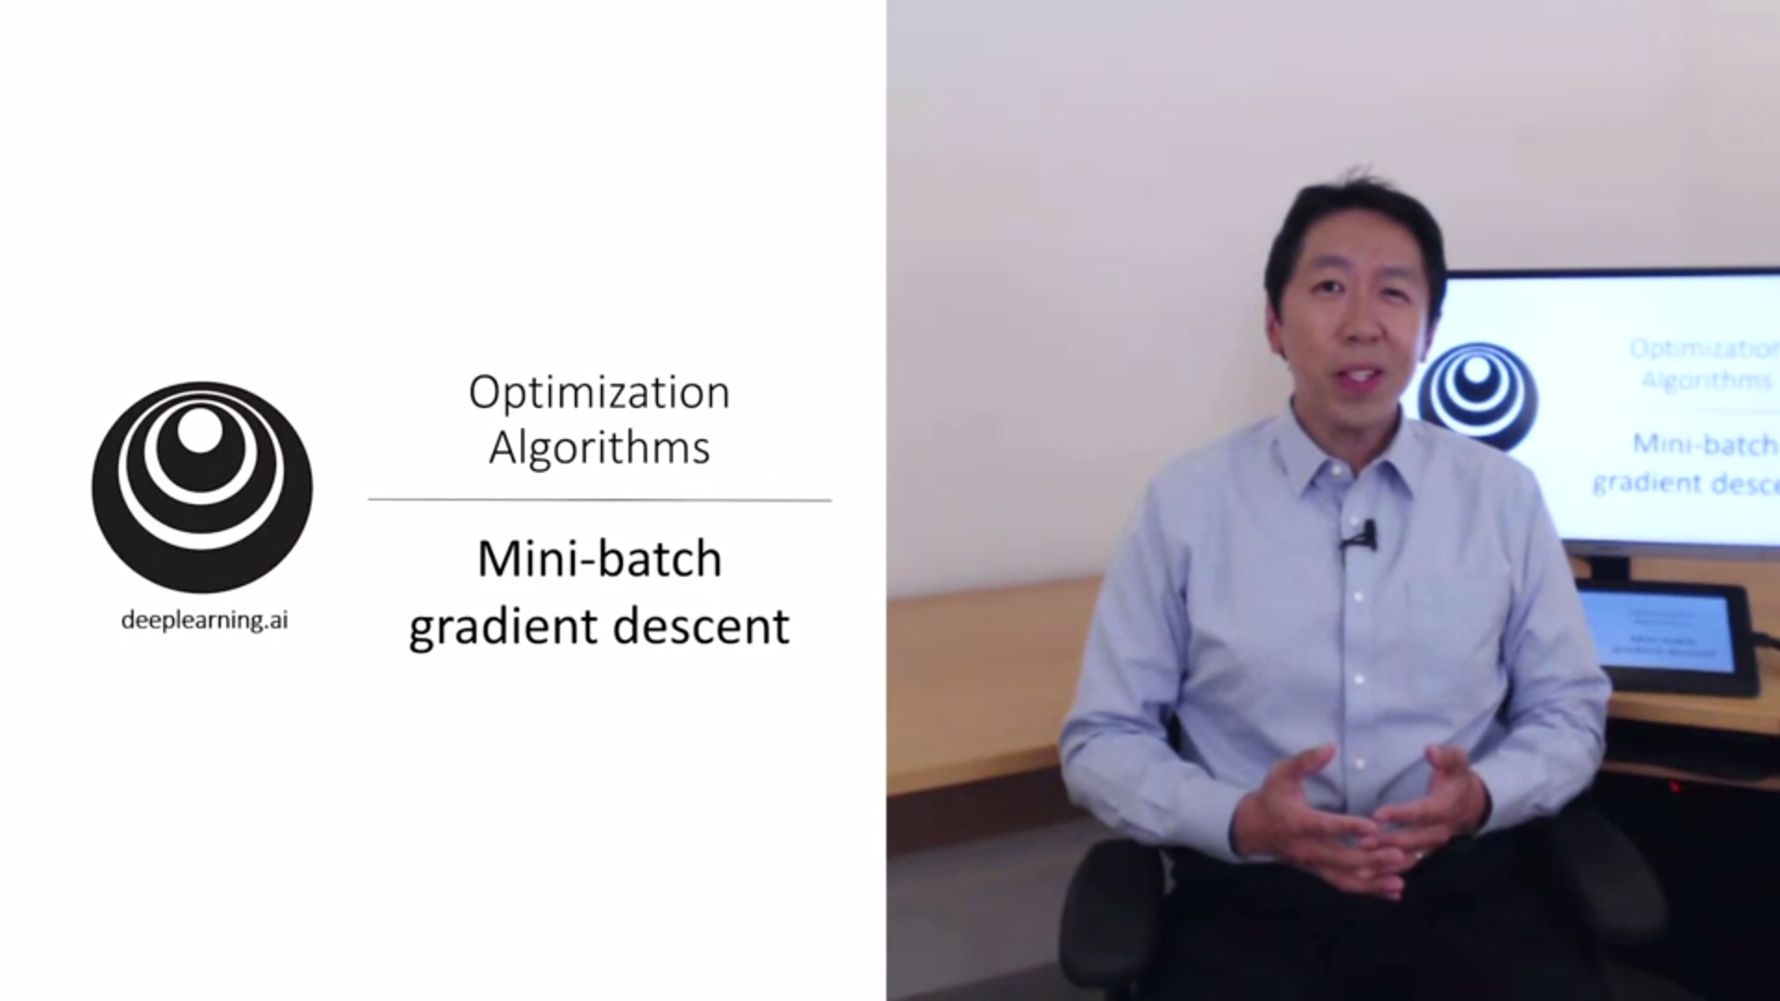

In this week we learn about optimization algorithms that enable us to train neural networks much faster. Since training models is a very iterative process it really helps to train models quickly. Having fast optimization algorithms can really speed up the efficiency of a deep learning team.

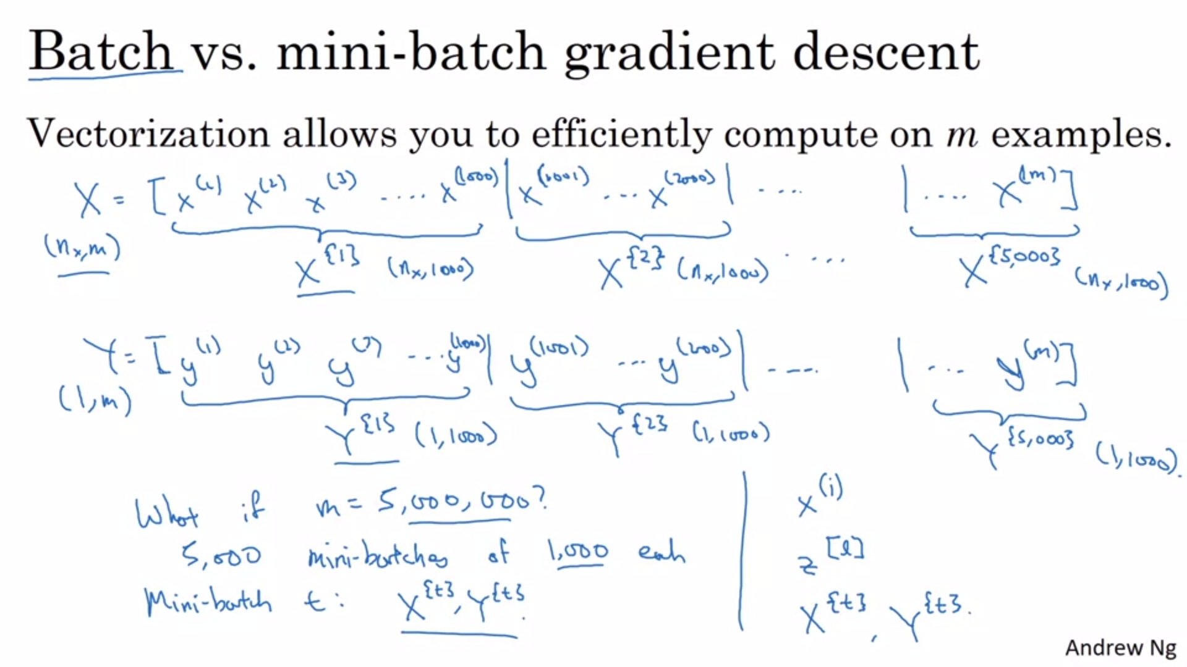

If m is large even with vectorization we will be slow if gradient descent takes all examples for each step. We can let gradient descent make progress even before we process the entire training set. Split your training set in minibatches.

The notation for the mini batch index will use curly brackets.

The gradient descent algorithm that uses the entire training set for one step is also called batch gradient descent.

With minibatch gradient descent you will only process a single batch once at a time.

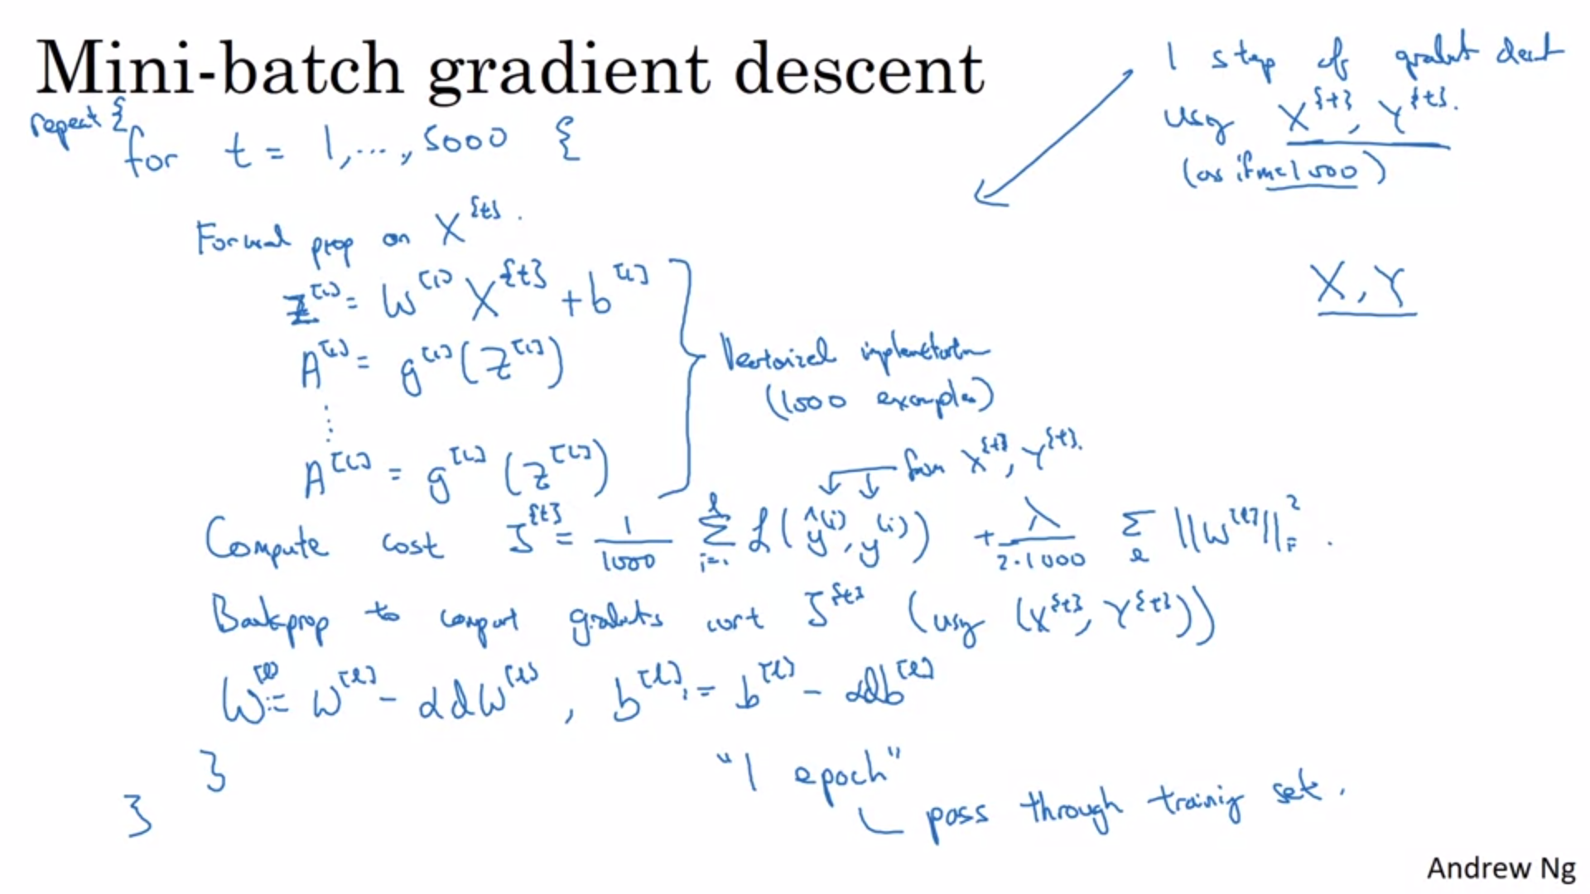

All examples within a minibatch will still use vectorization.

The cost is indexed because it is the cost for one mini-batch.

Everything is basically the same only that we are using a subset of the training example.

1 epoch -> single pass through the training set. With mini-batch gradient descent you will take multiple steps during one epoch as opposed to batch gradient descent where you take one step per epoch.

With a large training set mini-batch will run much faster and it is pretty much what everyone in deep learning will use.

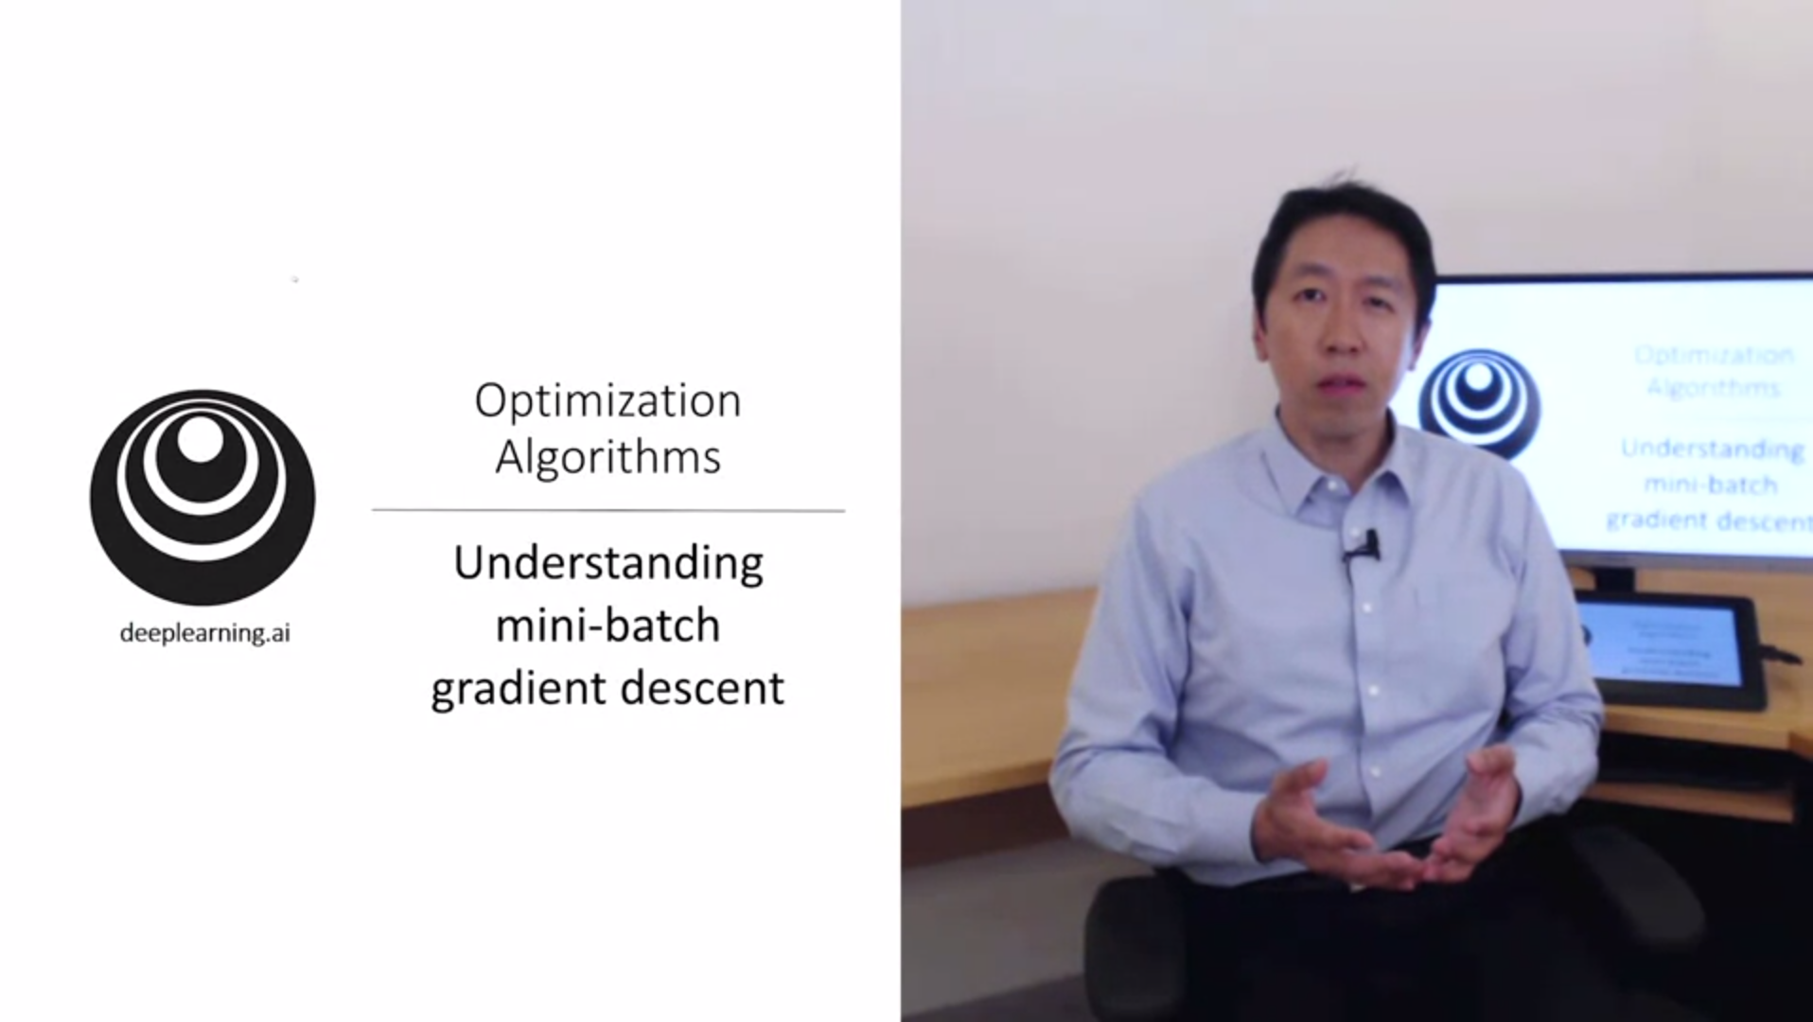

We will learn more details about mini-batch gradient descent.

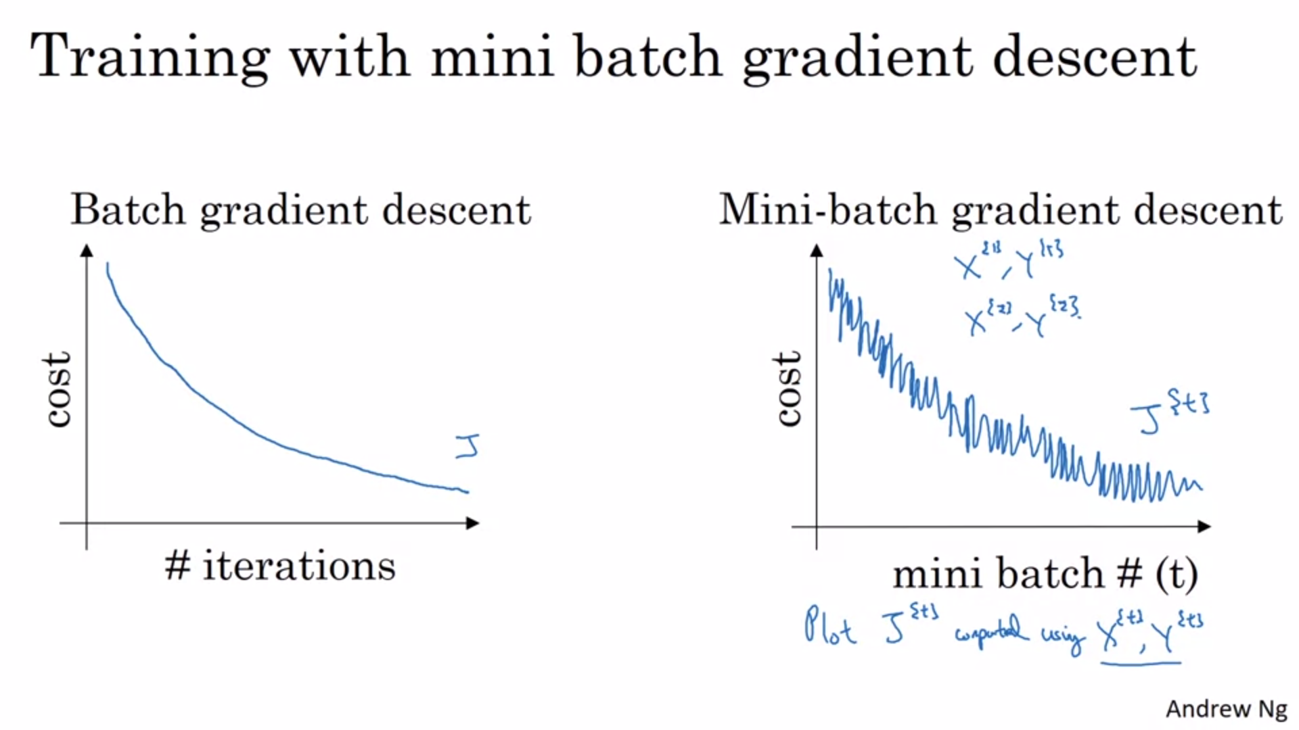

With batch gradient descent the cost should always go down on every iteration. If that is not the case there will be something wrong.

This is not the case for mini-batch gradient descent. It will be a bit noisier but still trend downwards.

One batch could be more difficult than another or even have a mislabeled data point in it.

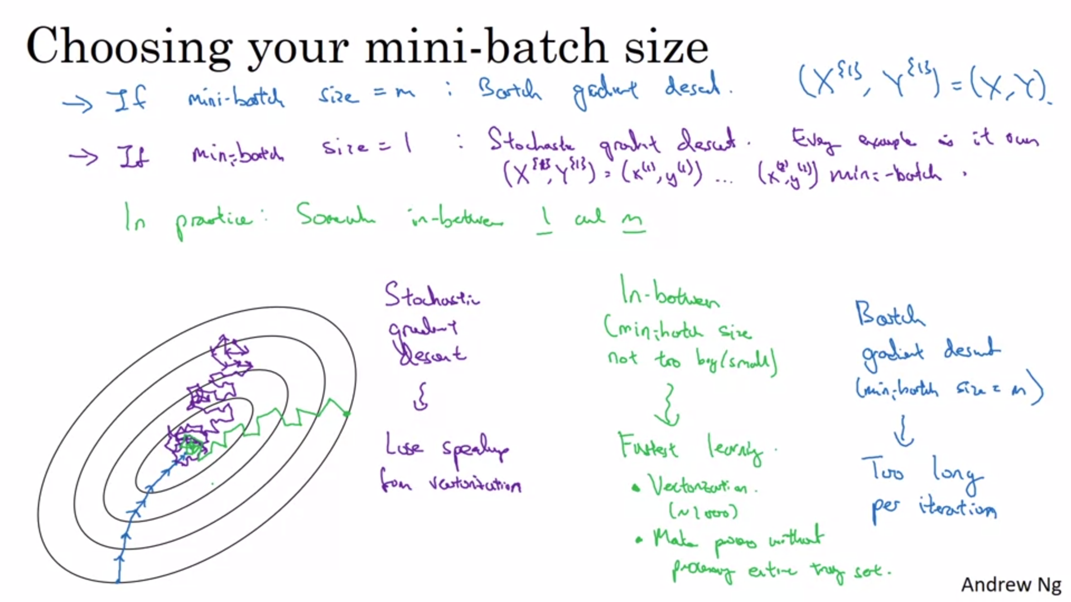

There are two extremes: batch gradient descent and stochastic gradient descent.

Stochastic gradient descent (purple) is extremely noisy and can go into the wrong direction as well. It will never converge.

In practice what you do is choose something in between the extremes (mini-batch gradient descent).

The main disadvantage of batch gradient descent is that it takes too long with a large dataset.

The main disadvantage of stochastic gradient descent is that you cannot use vectorization (the noisiness is not so much the problem). -> It is very inefficient.

Mini-batch also does not exactly converge but it is less noisy than stochastic gradient descent. We can reduce the learning rate. We will see that later.

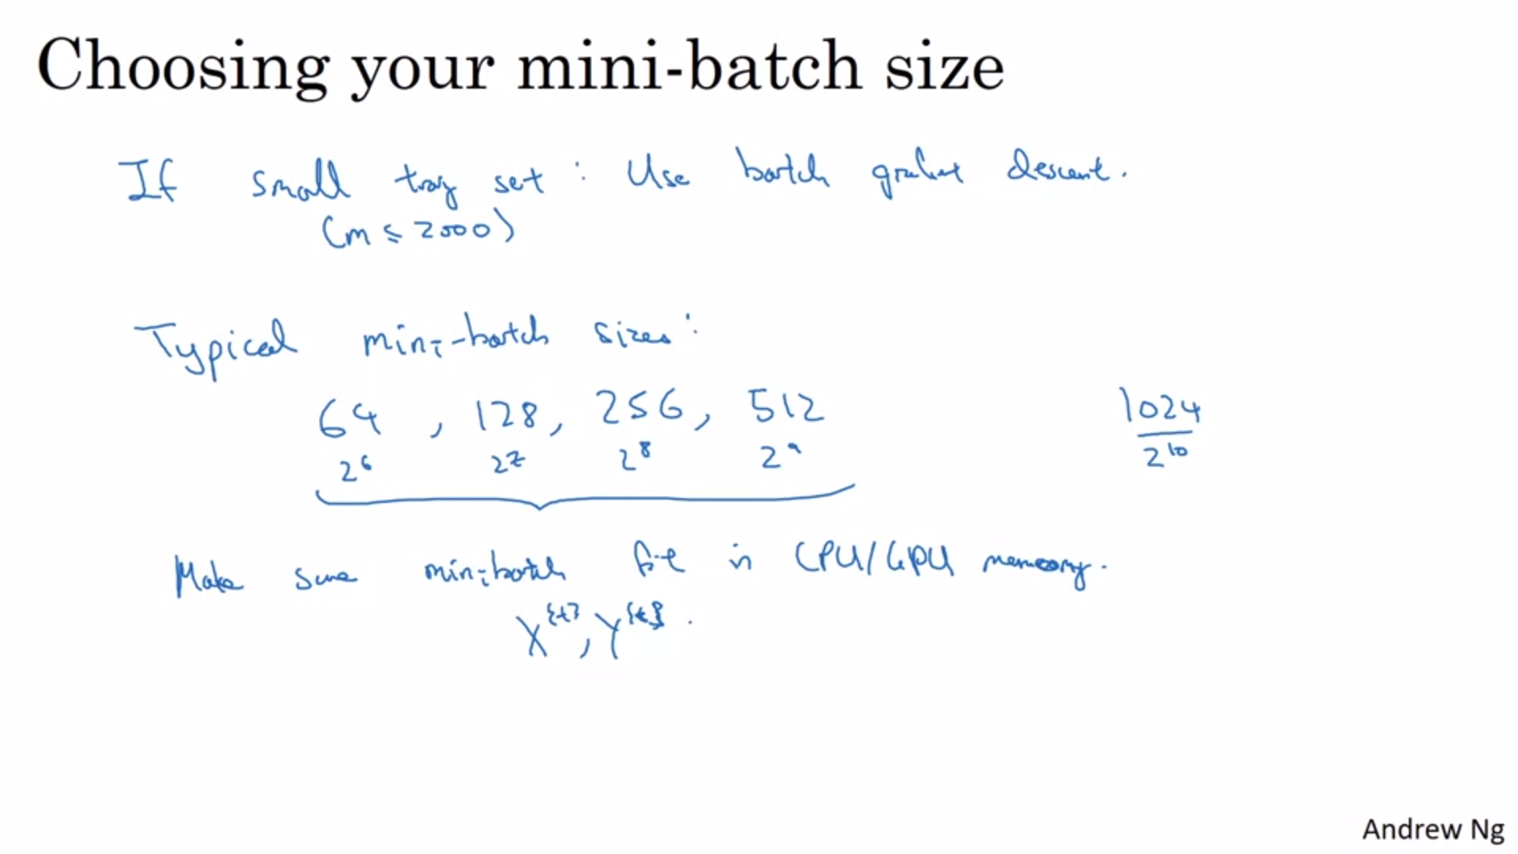

How do you go about choosing the mini-batch size?

Small training set means < 2000.

Because of the way computer memory is laid out in access, sometimes the code runs faster if the mini-batch size is a power of 2.

In practice the mini-batch size is another hyperparameter. Andrew would try several different values of the range indicated on the slide.

It turns out that there are even more efficient algorithms than mini-batch gradient descent. We will now talk about them in the coming videos.

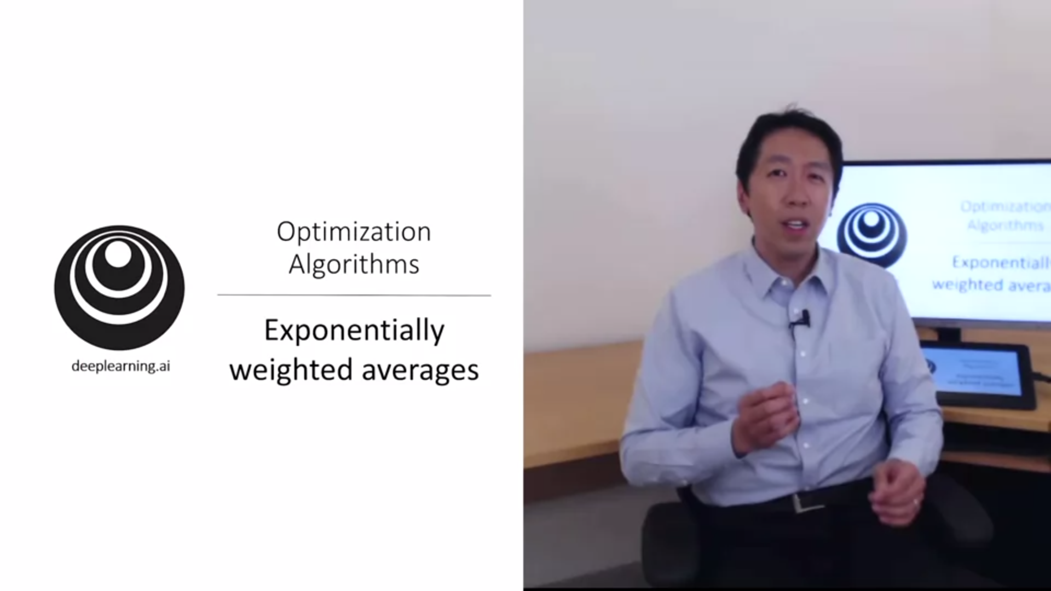

In order to understand the coming optimization algorithms we will need to understand exponentially weighted averages.

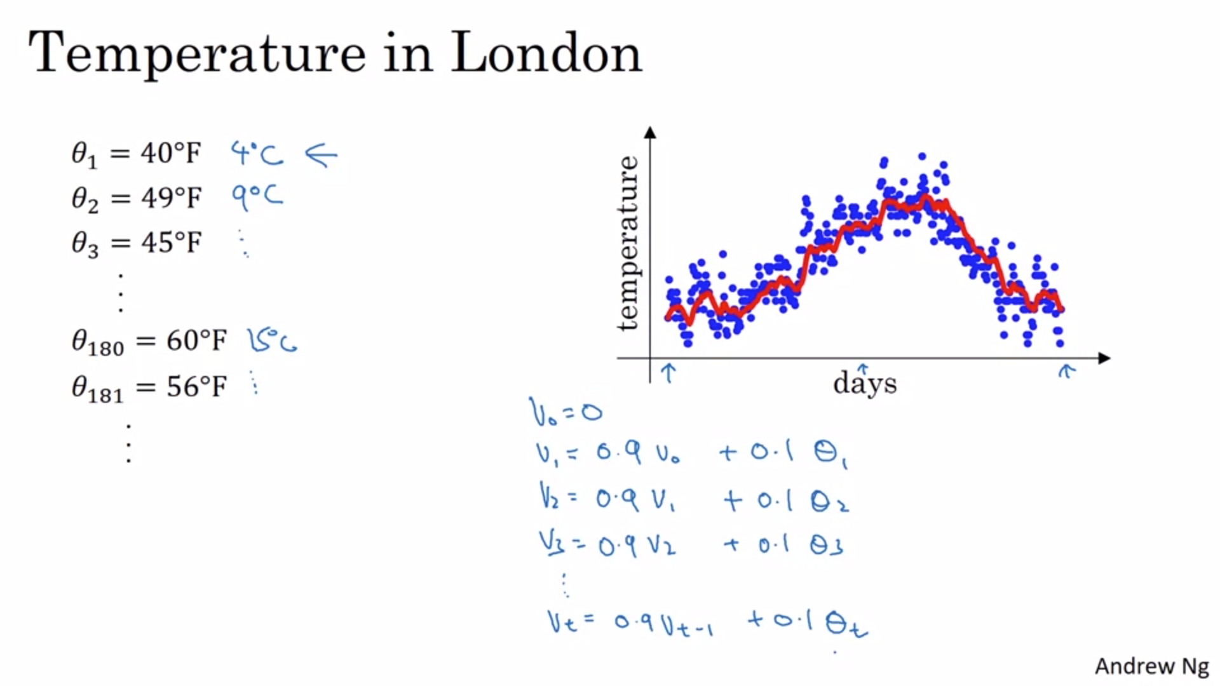

Temperature measurements from January to end of year. This data looks a bit noisy. If we want to compute the trends (local average) this is what we can do -> weighted average.

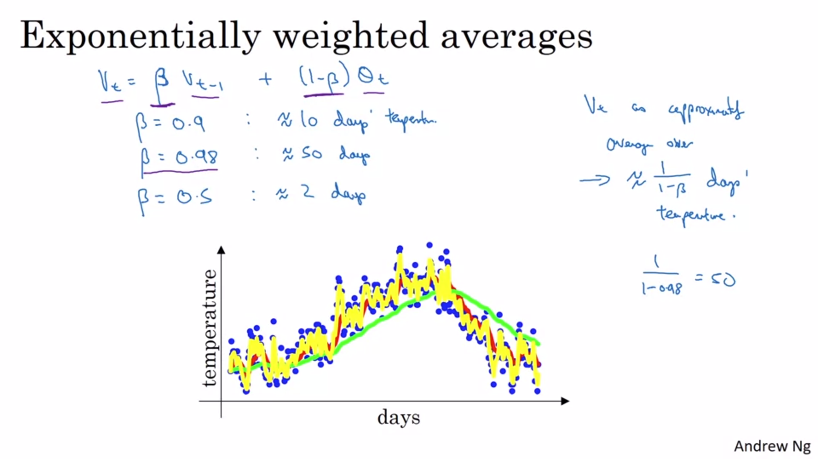

With a high value of beta we get a smoother plot but on the flipside the curve is also shifted to the right. The weighted average formula will adapt slower.

The lower beta the more susceptible you are to outliers but the faster you adapt.

Beta will also be a hyperparameter of the learning algorithm.

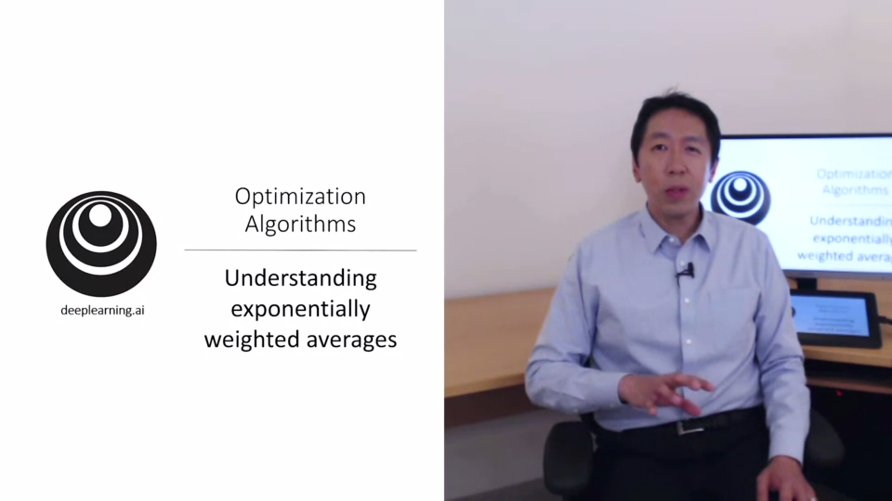

Exponentially weighted averages will be a key of more advanced optimization algorithms.

Let’s look at the math.

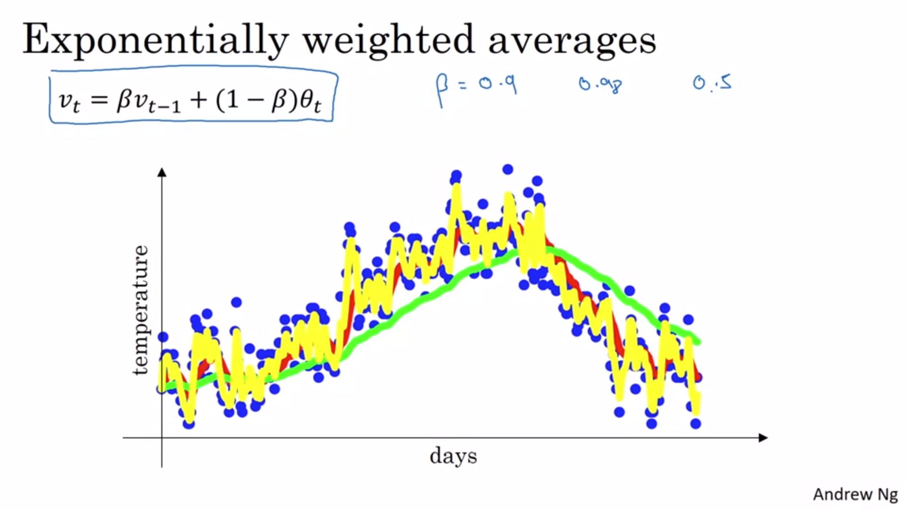

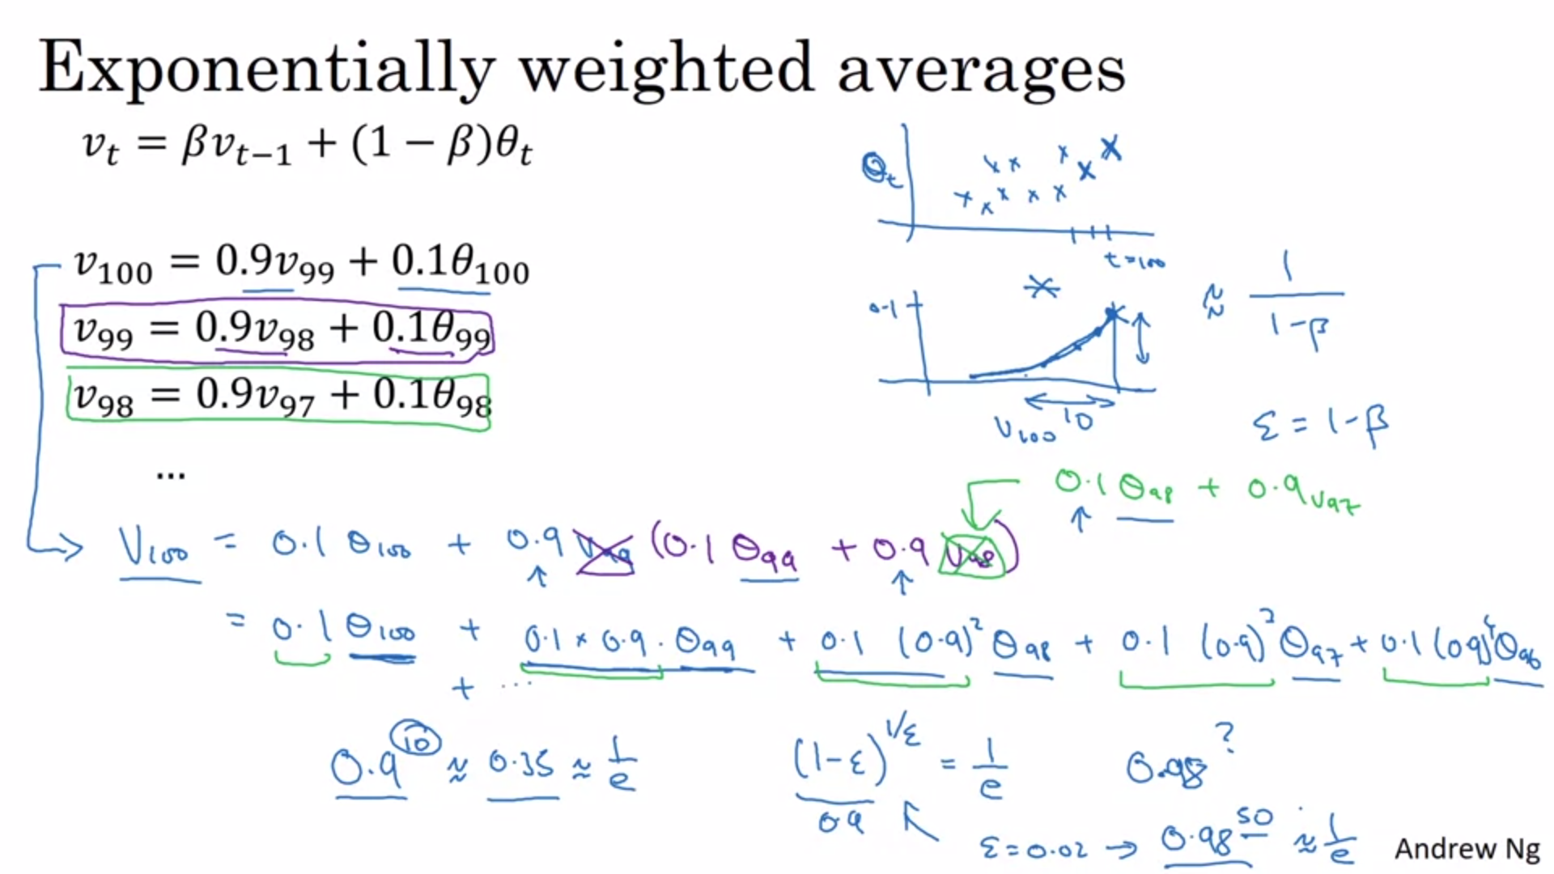

Plug in terms into recursive definition.

In terms of the thetas we will have an exponentially decaying function (see plot on the top right).

Multiply the daily temperature (plot 1) with the exponentially decaying function (plot 2) and sum it up. This becomes v_100.

It turns out that all the coefficients will add up almost to 1 (up to the bias correction).

In this example, epsilon would be 0.1. 1/epsilon would be 10. It takes about 10 days for the height of this to decay to around 1/3.

For epsilon of 0.02 it would take 50 days.

This is just a rule of thumb not a formal mathematical statement.

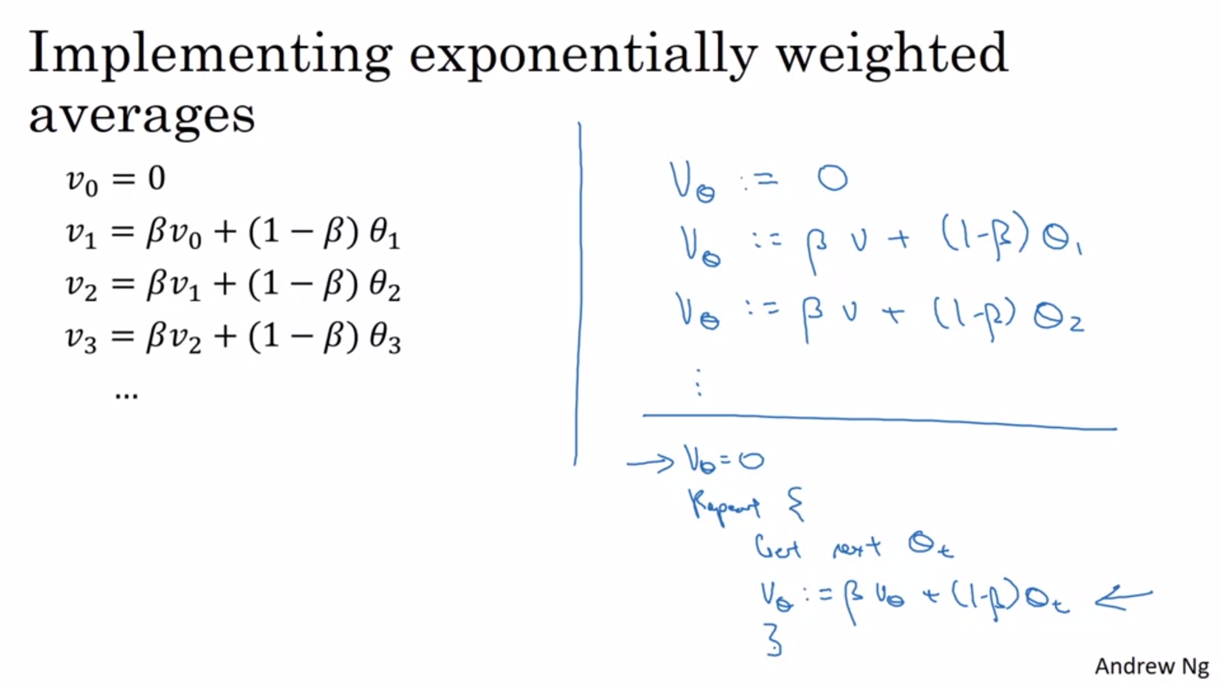

You keep on overwriting v values. This is very efficient in memory storage. You only need to store 1 value. Although it is really not the best way to compute an average. It would be better to keep values and divide by the number of values. But this is computationally more expensive and also more complicated.

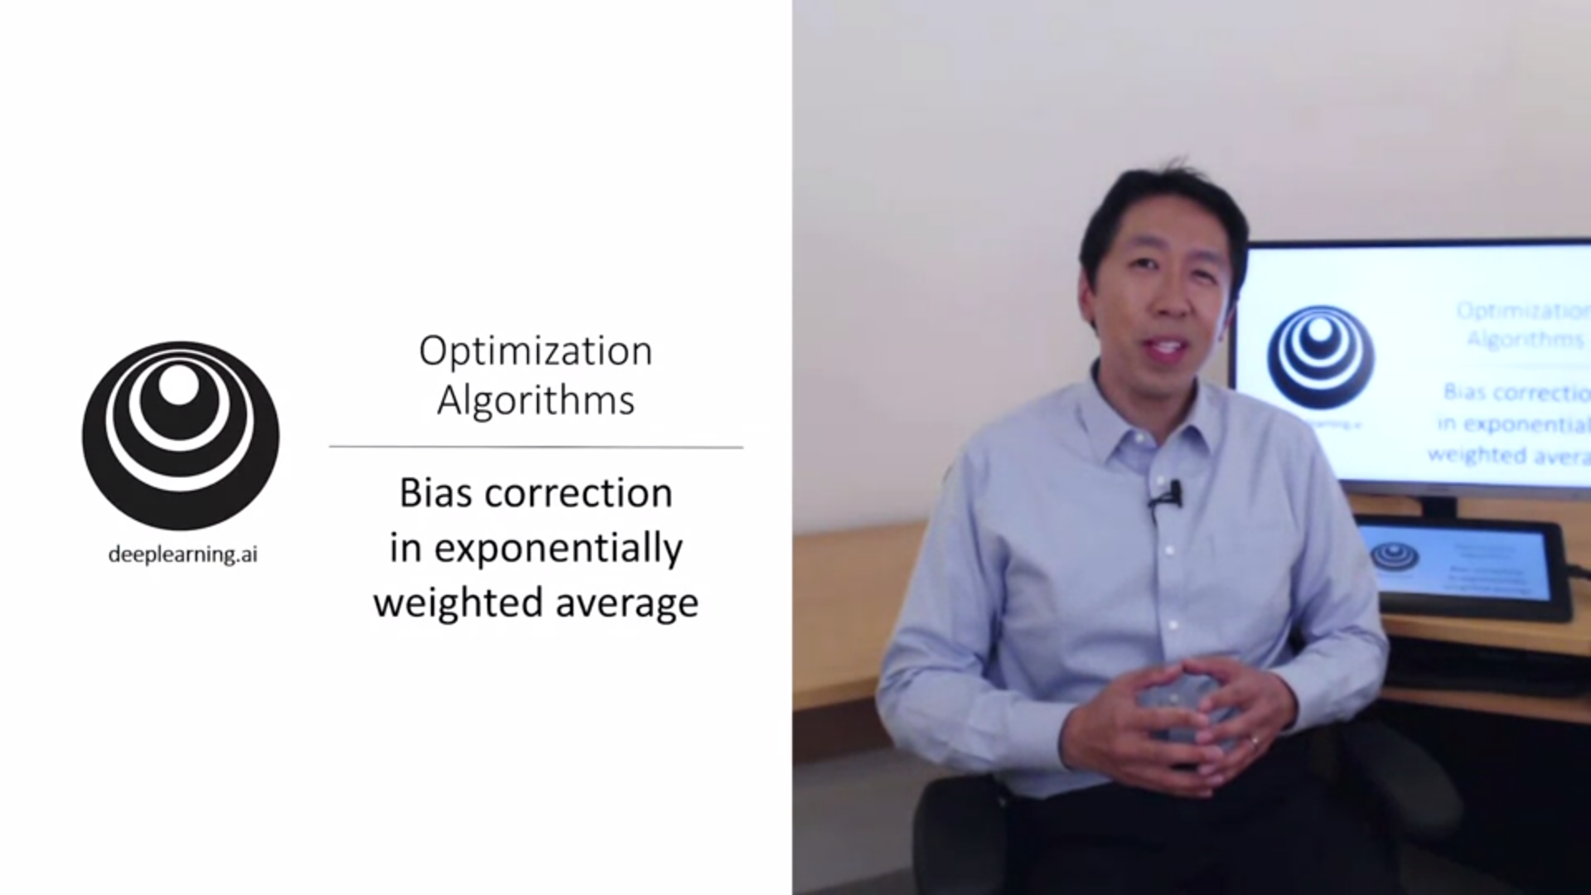

There is one technical detail that will make the calculation of weighted averages more accurate: bias correction.

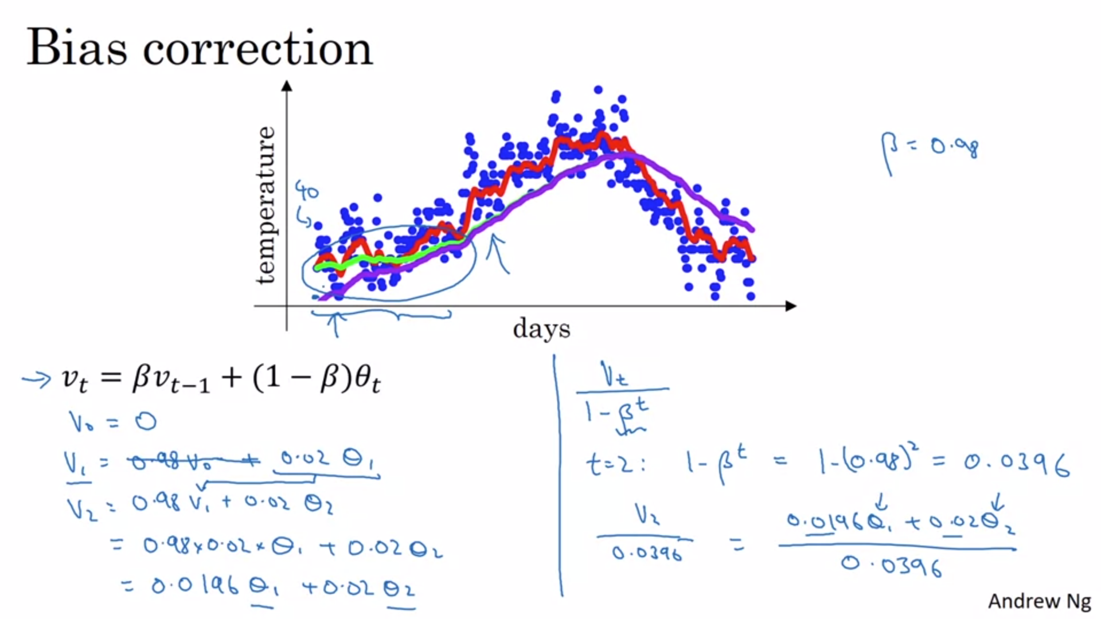

With beta = 0.98 you will actually get the purple curve instead of the green curve. V_0 is 0 so the first few values will not be very good values for the average temperature.

There is a way to modify this estimate to make it much better during the initial phase (see right side of the slide).

As t becomes large, beta^t will become 0 and the bias correction will not make any difference anymore. So it helps to warm up but at some point the lines will be the same.

In machine learning lots of people do not bother about bias correction. They would rather wait that initial time until the estimate is not biased anymore.

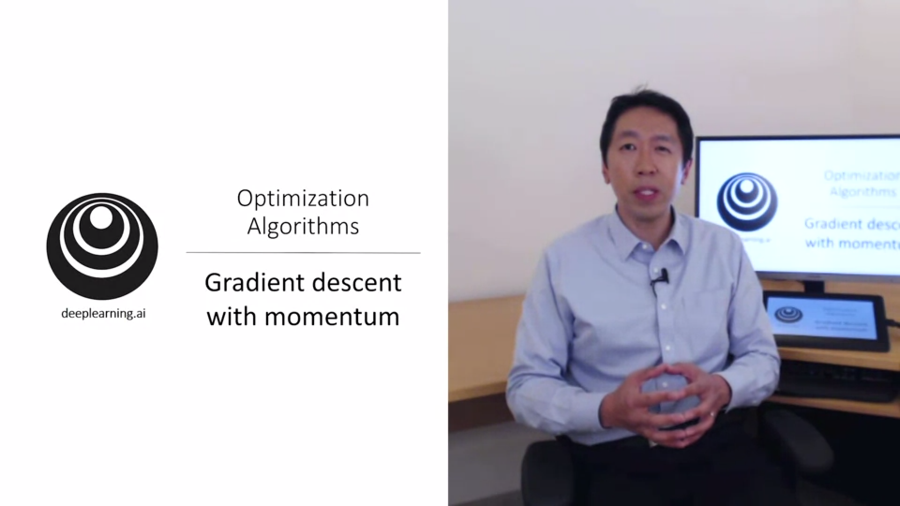

This almost always works faster than normal gradient descent. The basic idea is to compute an exponential average of the gradient and use that instead of the gradient.

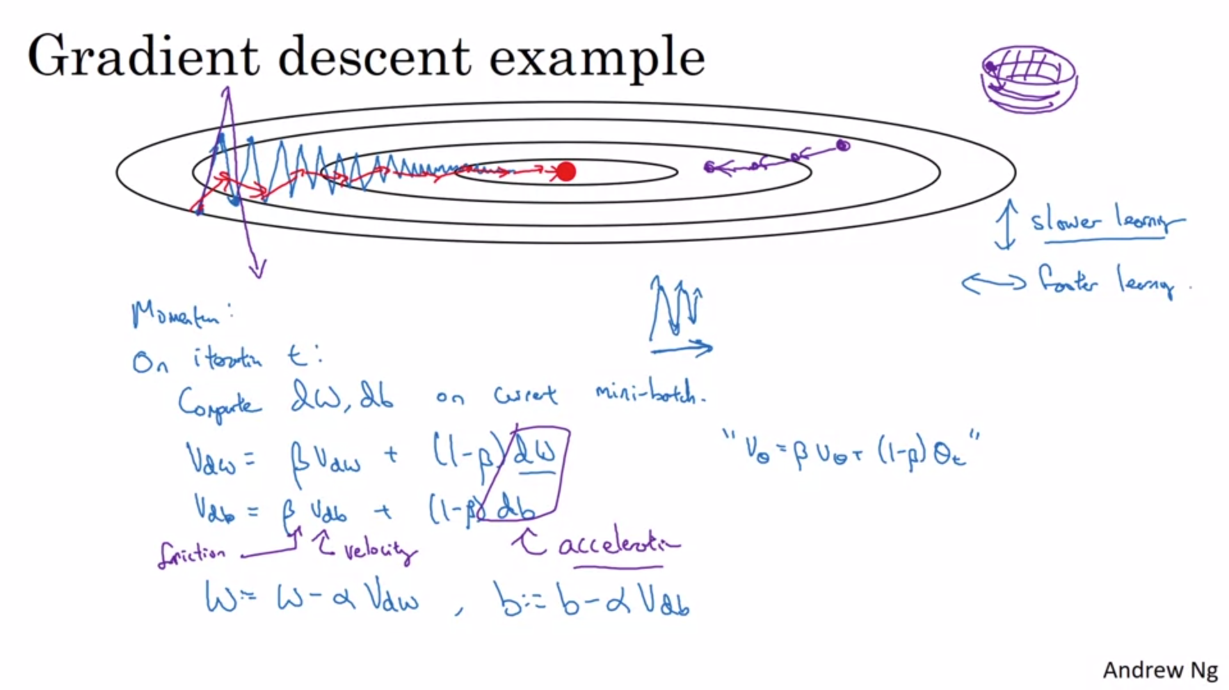

Gradient descent will slowly oscillate towards the minimum. This slows down gradient descent. If you choose to big a learning rate, you might overshoot (purple). So you have to choose a smaller learning rate.

We want the learning to be slower on the vertical axis but faster training on the horizontal axis.

Smooth out the gradients with exponentially weighted average. The oscillations in the vertical direction will average out to something closer to 0. In the horizontal direction all the derivatives are pointing to the right, so the average will still be big. This leads to the algorithm taking a more forward path (red line).

This also works on batch gradient descent.

One intuition which works for some people is the ball bowl analogy. Beta is friction, derivatives are acceleration.

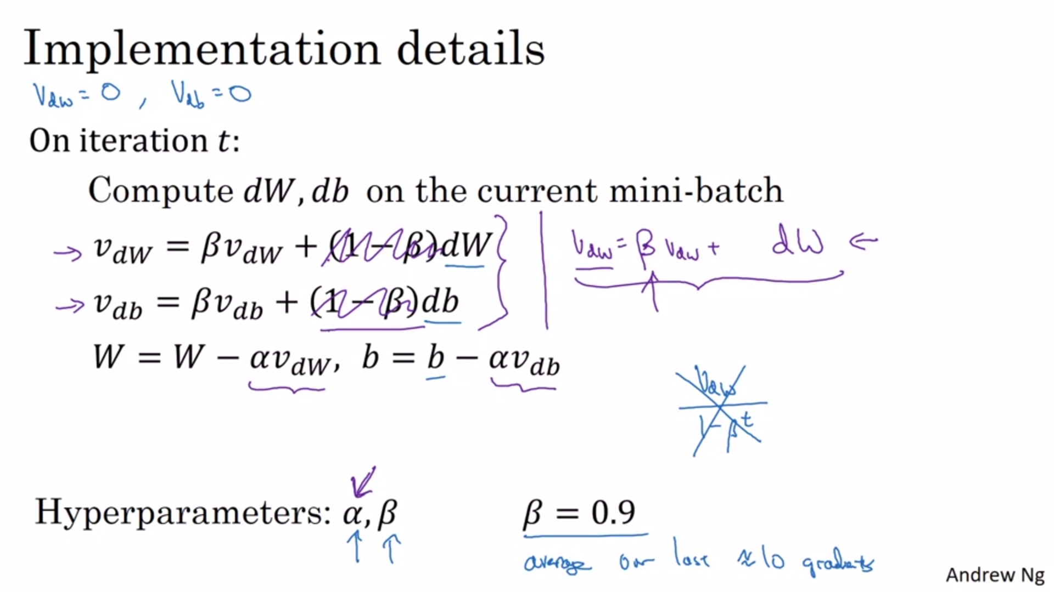

There are two hyperparameters now: alpha and beta. Beta=0.9 is pretty robust and works well.

In practice people do not bother with bias correction.

In the literature the “(1-beta)” term is often omitted. The net effect of this is that v_dw is scaled by a factor of 1-beta. This will be “integrated” in the alpha instead, so that the learning rate is affected.

These are two different versions.

There are still further things that can be done to speed up the optimization algorithm.

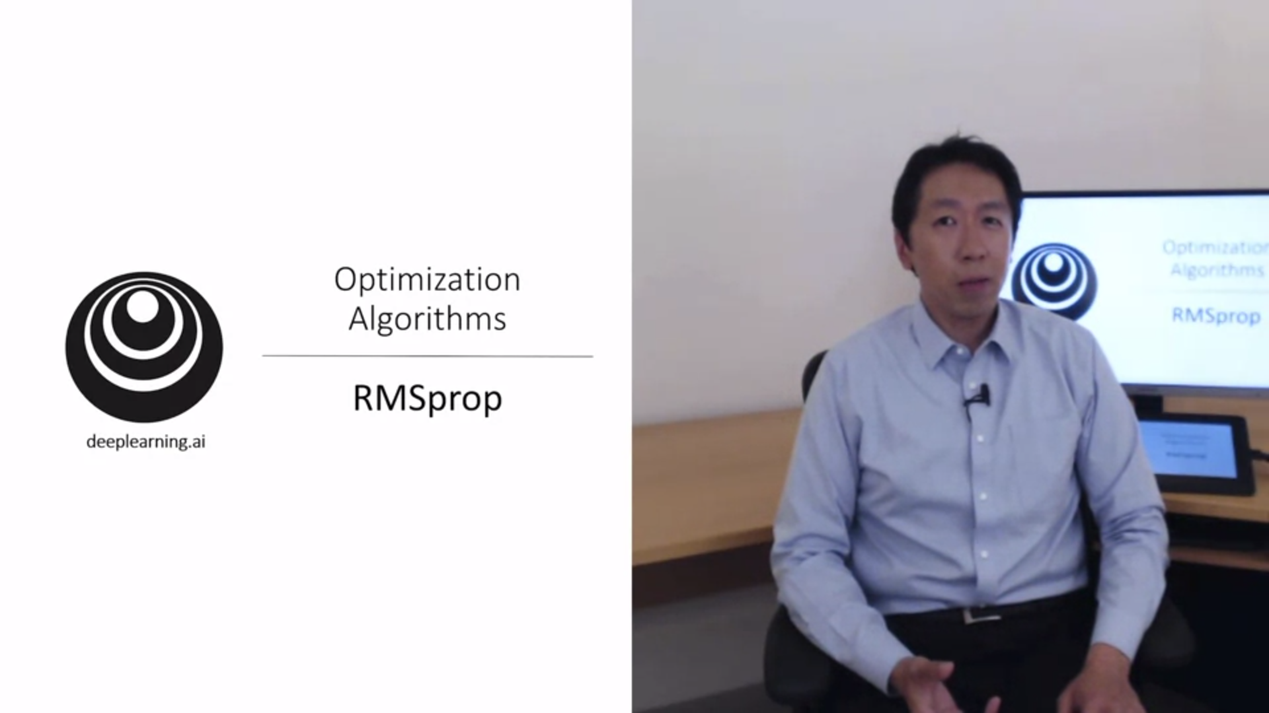

Root Mean Squared Prop.

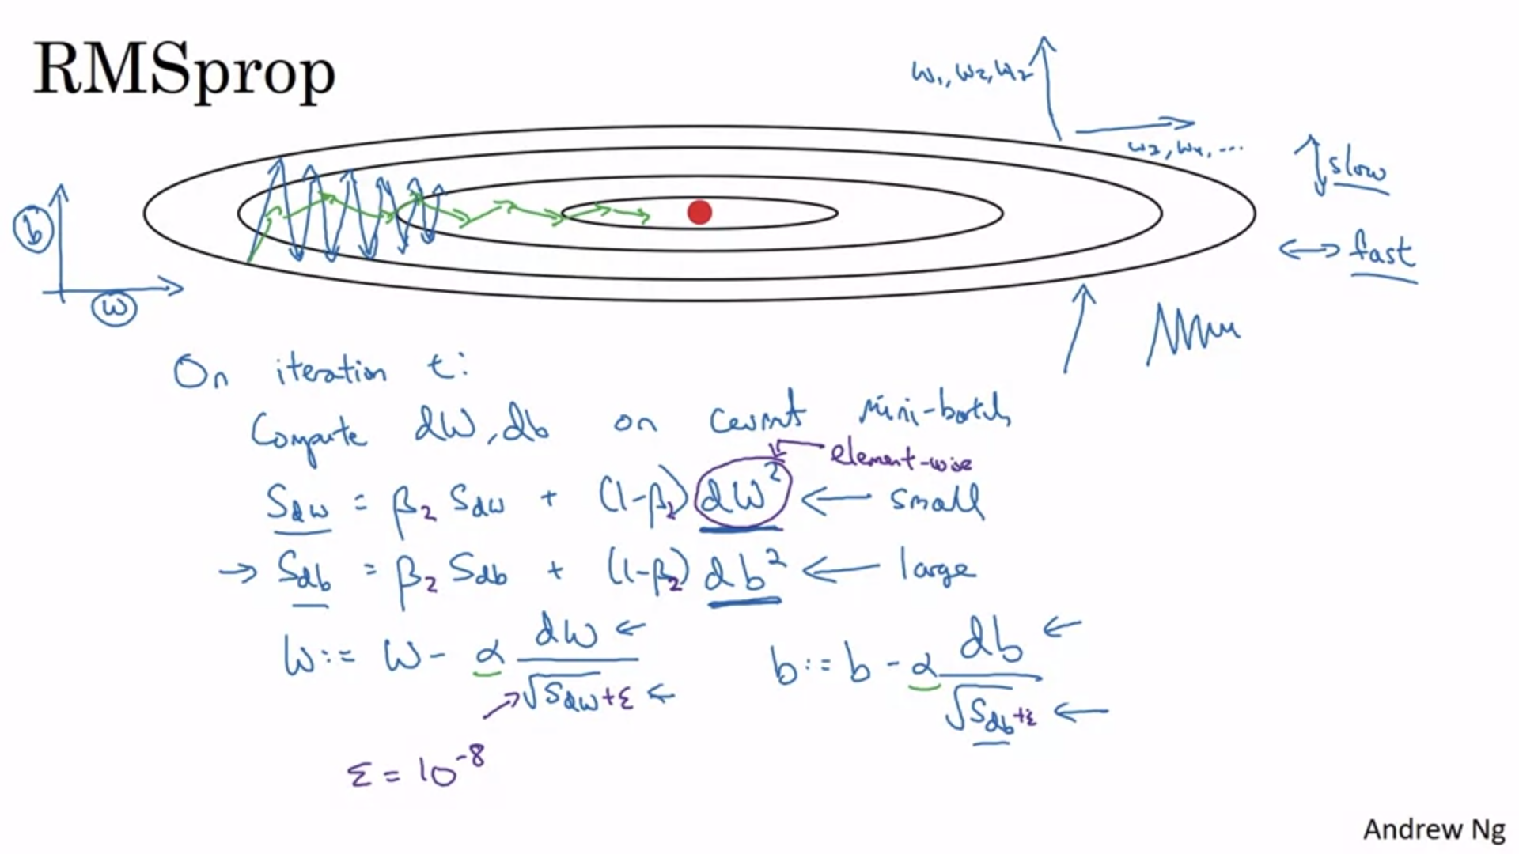

We look at b and w for the sake of intuition. This also works for multiple parameters w.

Now we replace v_dw with S_dw in terms of notation.

We will add an element-wise squaring operation to the exponentially weighted average.

We will add a division term.

Let’s look at the intuition: we are hoping that s_dw will be relatively small and s_db relatively large. This is the case if we look at the function. It is much more steeper in the vertical direction (b direction). This means that the update in the vertical direction is divided by a much larger number which helps to smooth out the oscillations.

One effect of this is that we can use a larger learning rate alpha without diverging.

Remember: In practice dw is very high dimensional.

In the next video we will combine momentum with RMSprop so we wil rename the parameter to beta_2. In addition we add a term in the denominator to ensure numerical stability (very small term epsilon).

Similar to momentum this algorithm will dampen out the oscillations in gradient descent.

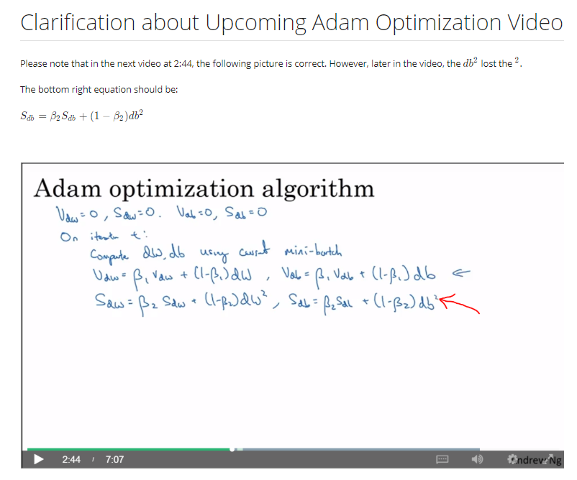

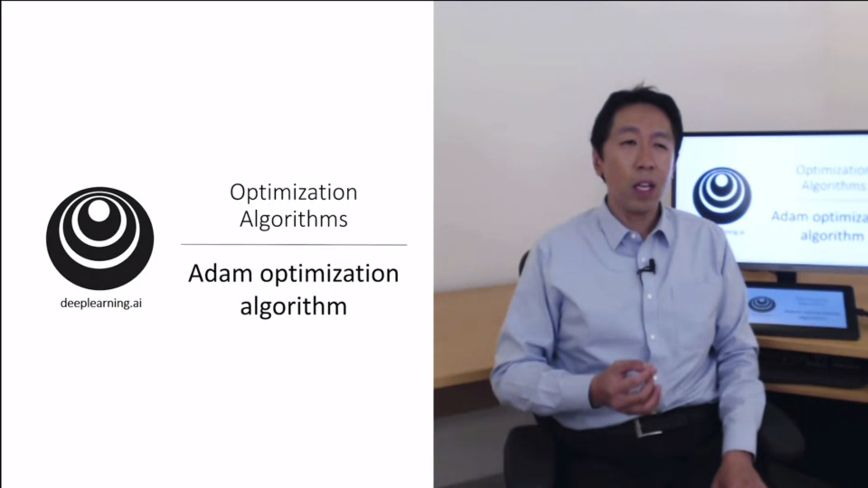

Adam is momentum and RMSprop put together.

Lots of researchers have proposed optimization algorithms that work well for particular problems. But most of them did not generalize well. Some skepticism evolved in the deep learning community whether there would be something better than momentum. Adam was one of the few algorithms that really generalized well and worked better.

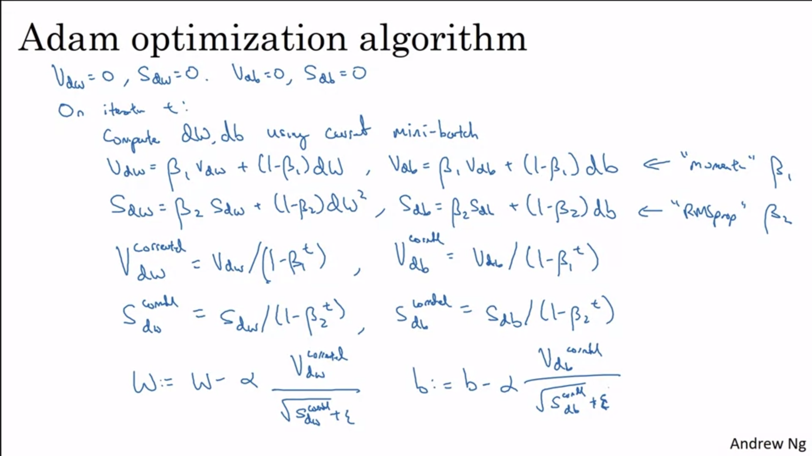

In the typical implementation of Adam we do bias correction.

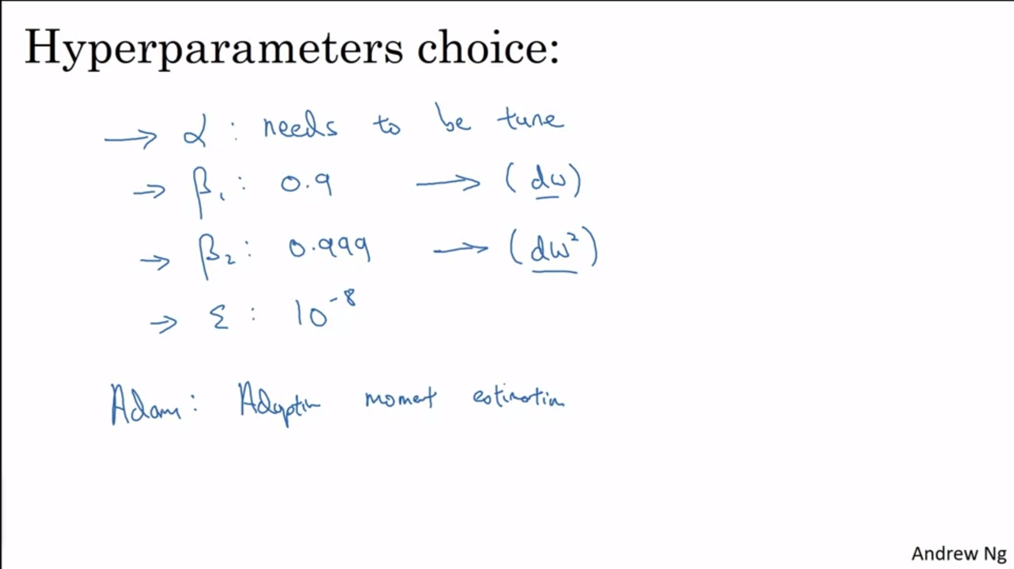

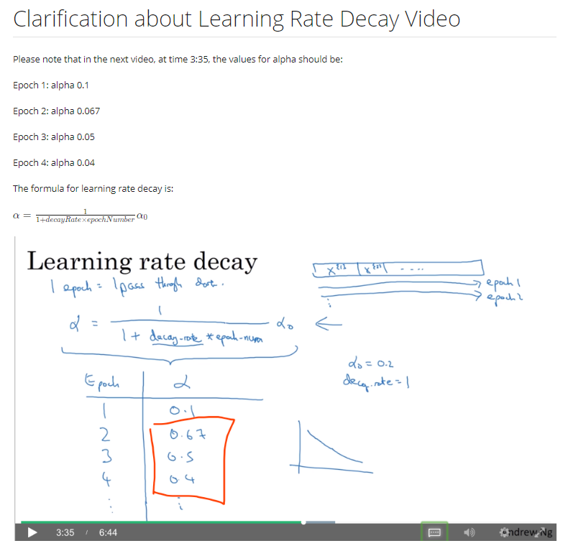

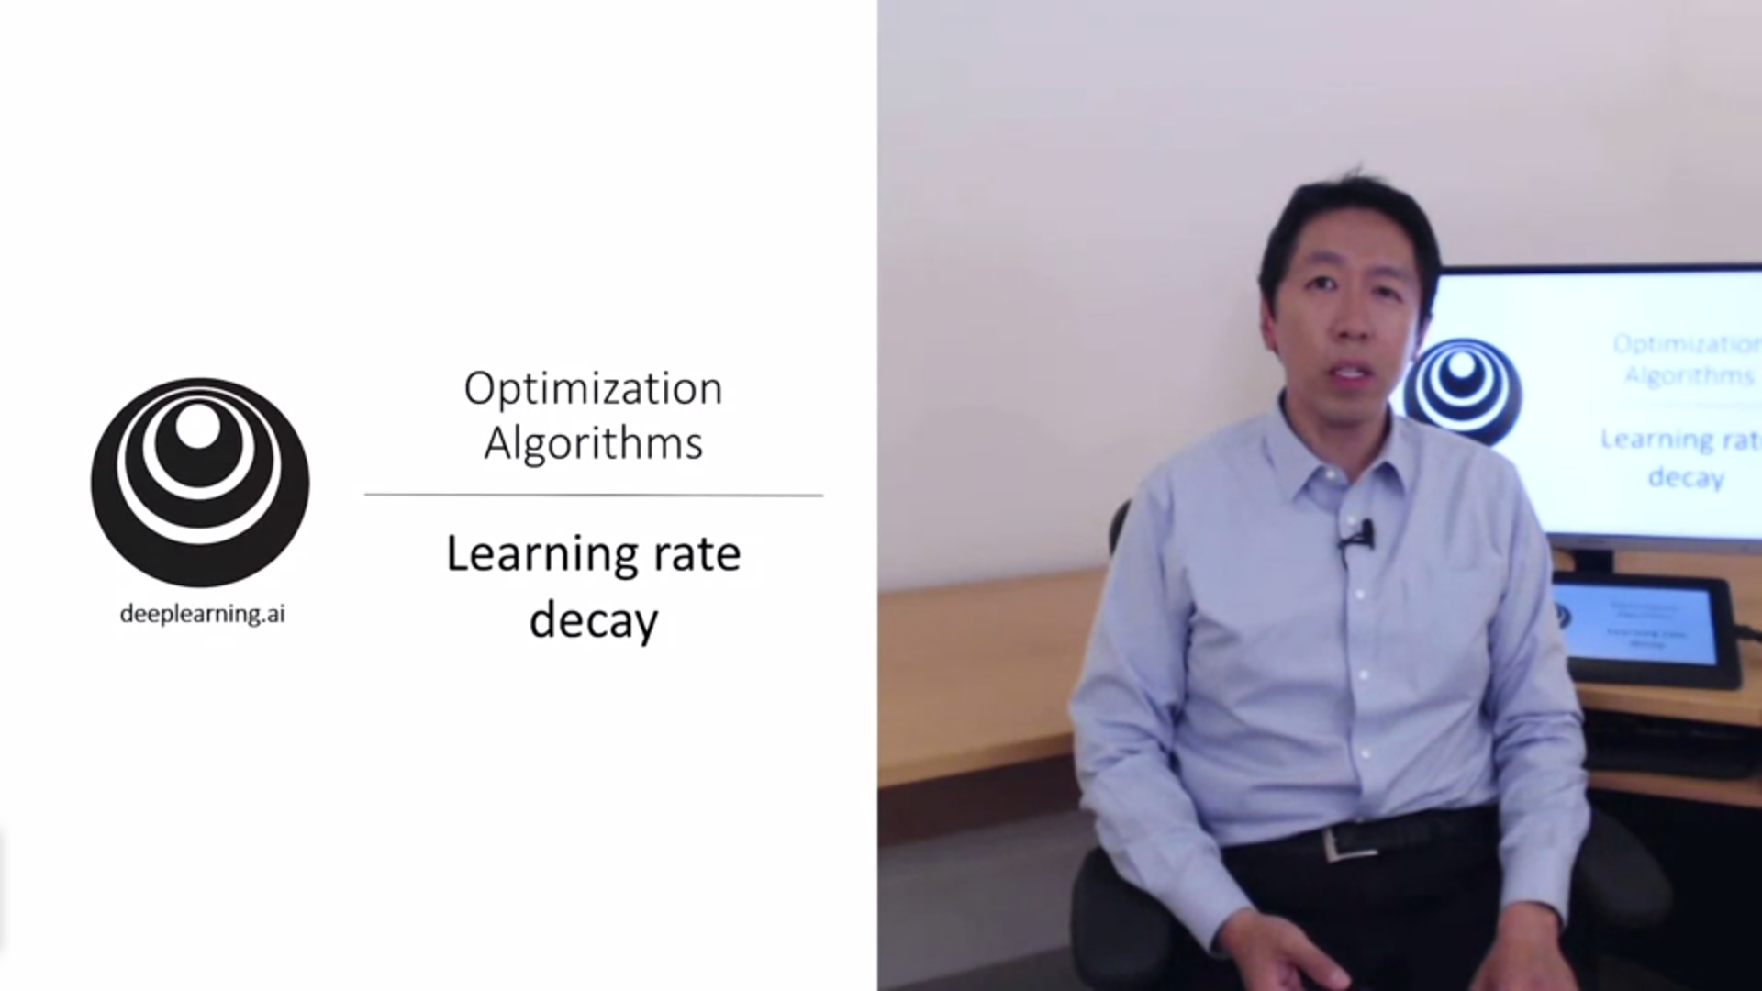

Slowly reducing the learning rate over time can further speed up the optimization.

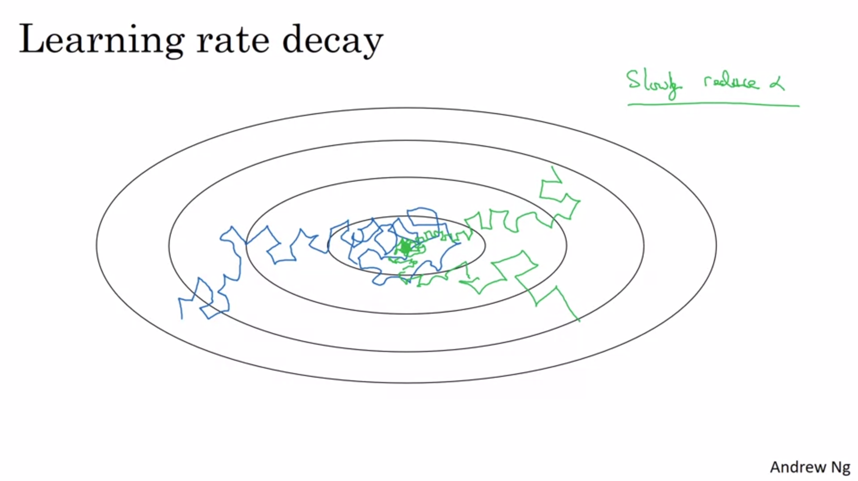

Without learning rate decay there will be quite a bit of noise and the algorithm will not converge.

When reducing the learning rate the oscillations at the end will get smaller.

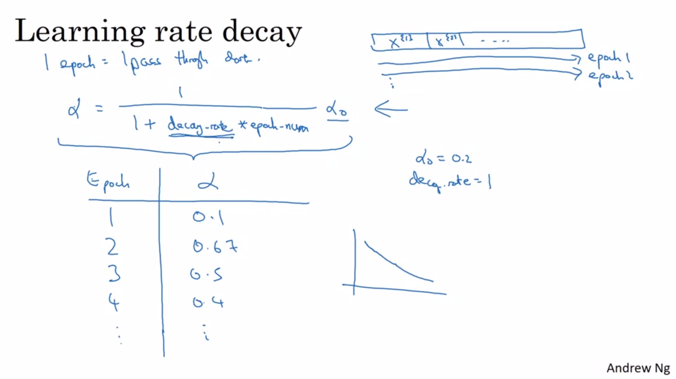

The decay rate becomes another hyperparameter to tune.

The learning rate decreases with the number of epochs.

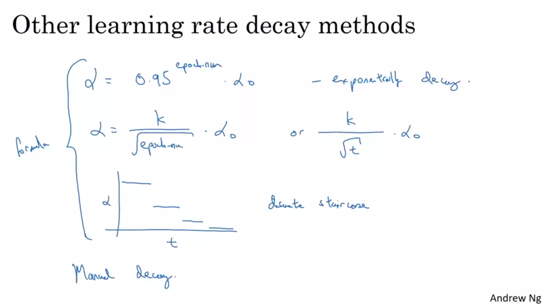

These are other methods to implement learning rate decay.

Manual decay can be used when only one big model is trained.

In the next week we will talk more about how to systematically choose hyperparameters. Alpha is definitely a more important hyperparameter than learning rate decay.

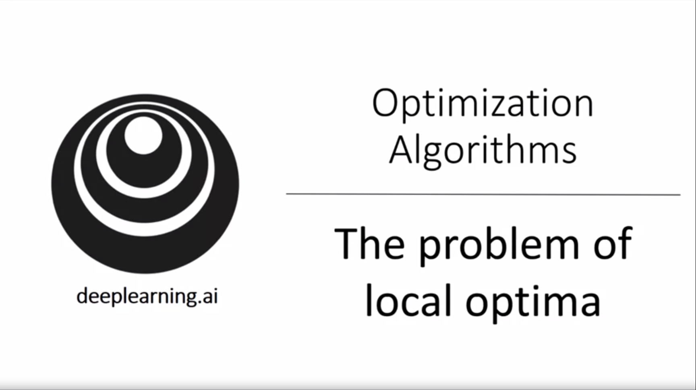

In the early days of deep learning people used to worry about the optimization algorithm getting stuck in local optima a lot. But theory has advanced.

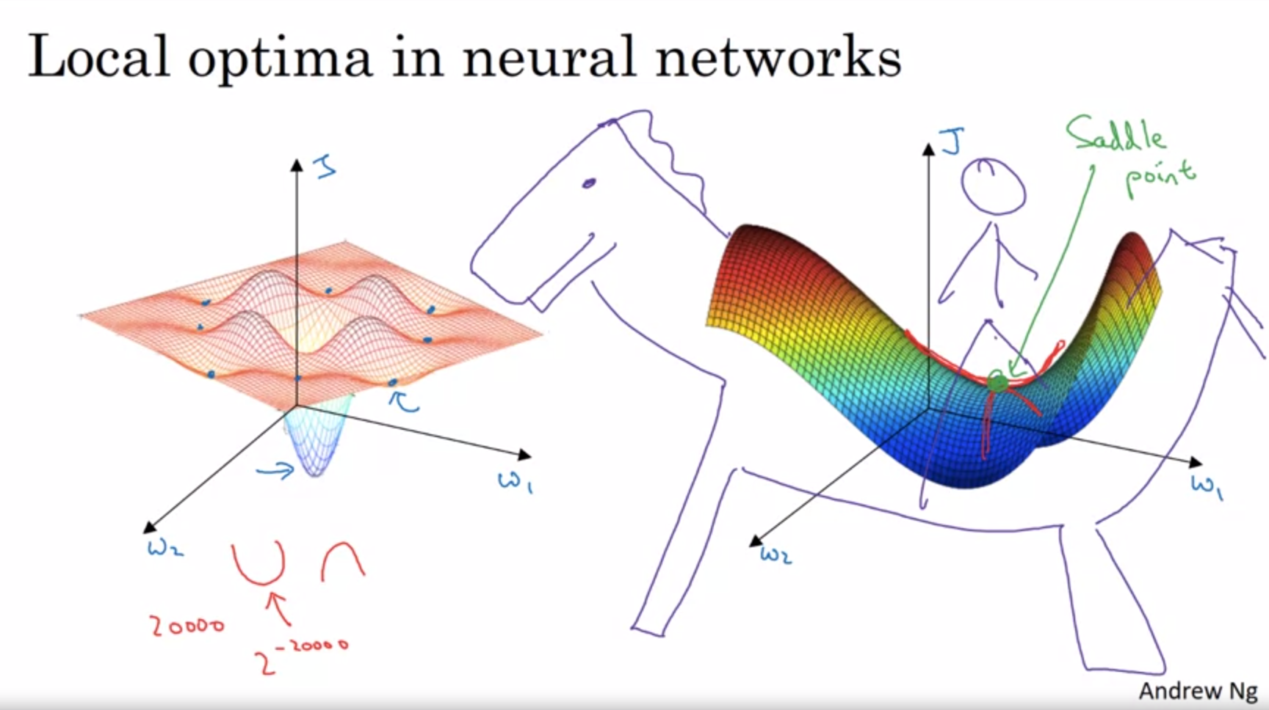

This was the 2d picture that people had in mind when thinking about getting stuck. It turns out that this intuition is not actually correct. For higher dimensional problems most points are not local minima but saddle points. In some direction there will be a way down. The red numbers are probabilities. A lot of the intuitions do not transfer from 2d to higher dimensions.

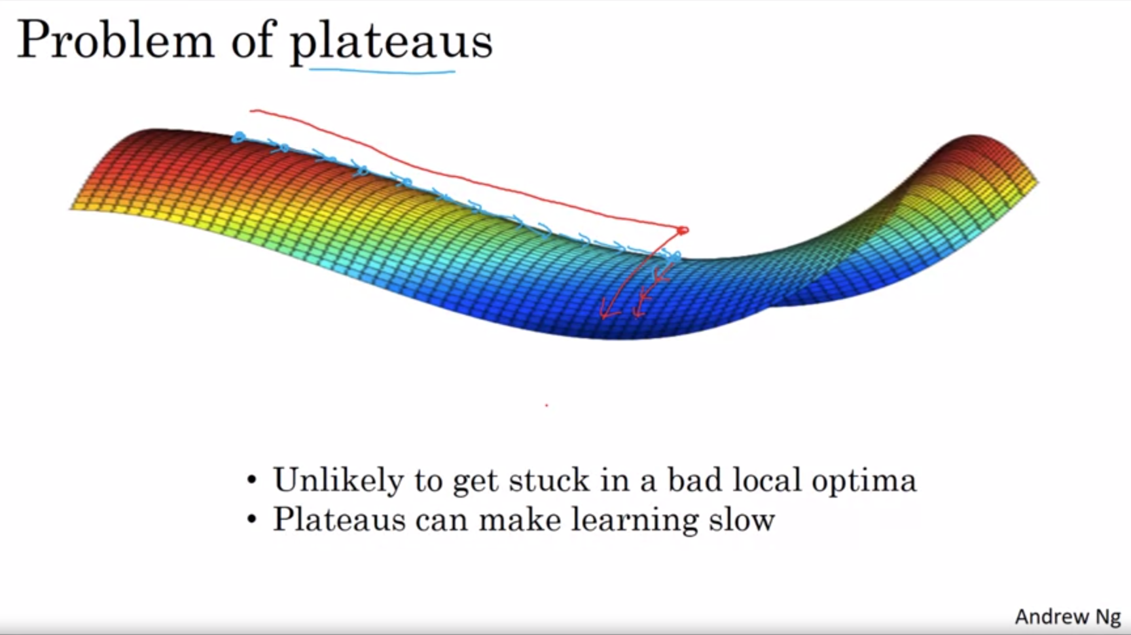

More sophisticated optimization algorithms like Adam will help to speed up the optimization in these cases.